Ordering
- From the Master Menu select Sales Processing
- Select Order Entry/Maintenance and select your printer
- Type the order # in the Order # box to open the order
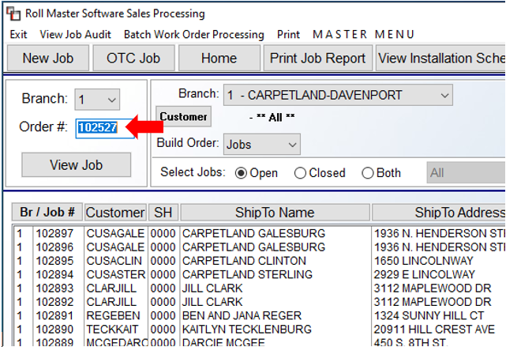
- Click on the item that needs ordered to select it and right click to bring up the following options:
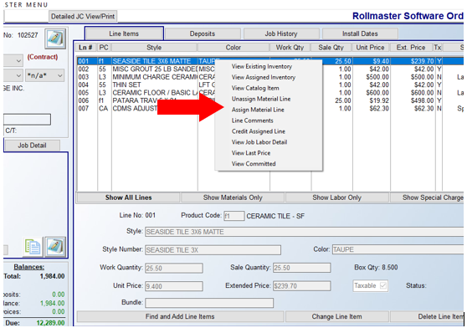
- Select Assign Material Line as pictured above

- On the Assign Inventory to Order screen select the From PO Tab (1) and then select New PO (2)
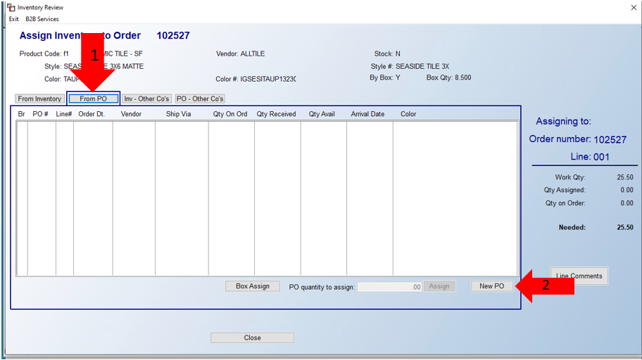
- The following screen will open:
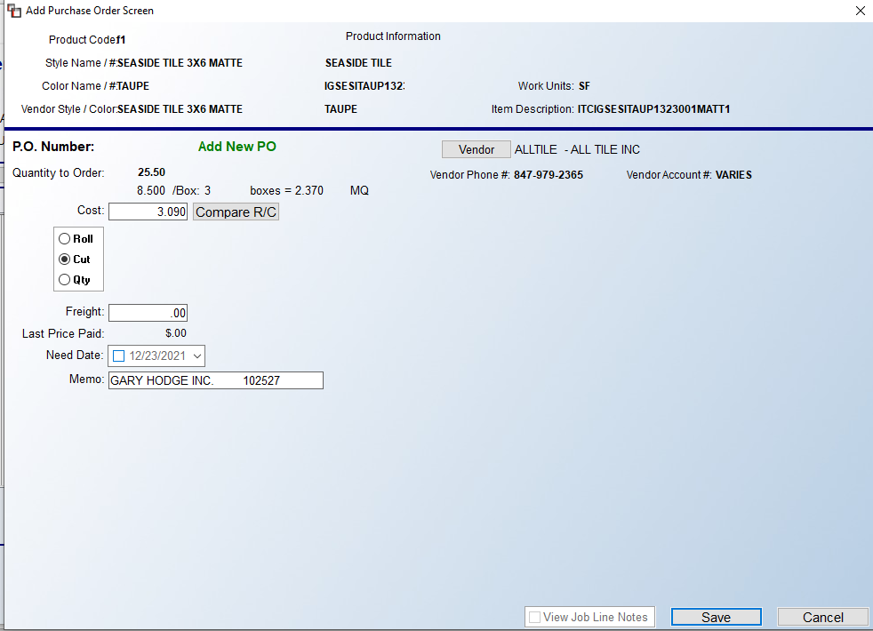
  - Verify Quantity to Order, Cost, Memo (long names may get cut off), and Vendor (if this is incorrect, click the vendor box and select the correct vendor)
- Click Save
- Purchase Order # will pop up after hitting Save. Write the PO info on the hard copy
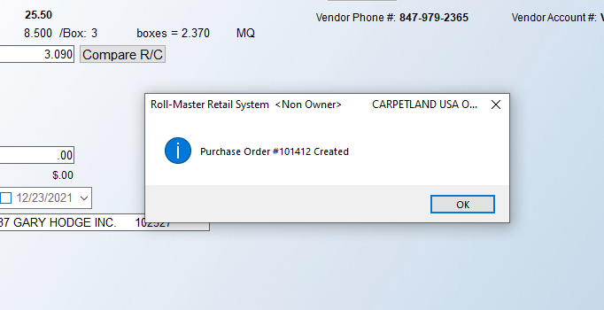
- Click OK and then exit until you are at the main order screen
- Under the Job Detail tab, change the Job Status to 2.0 Order – Material Ordered or 2.1 BO – Goods Back Ordered
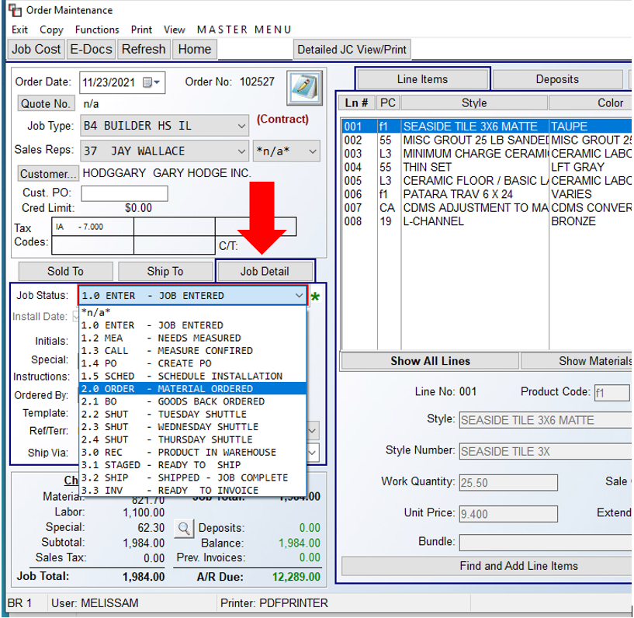
- Exit until you are back at the Master Menu and select Purchase Orders
- Open the PO you just created

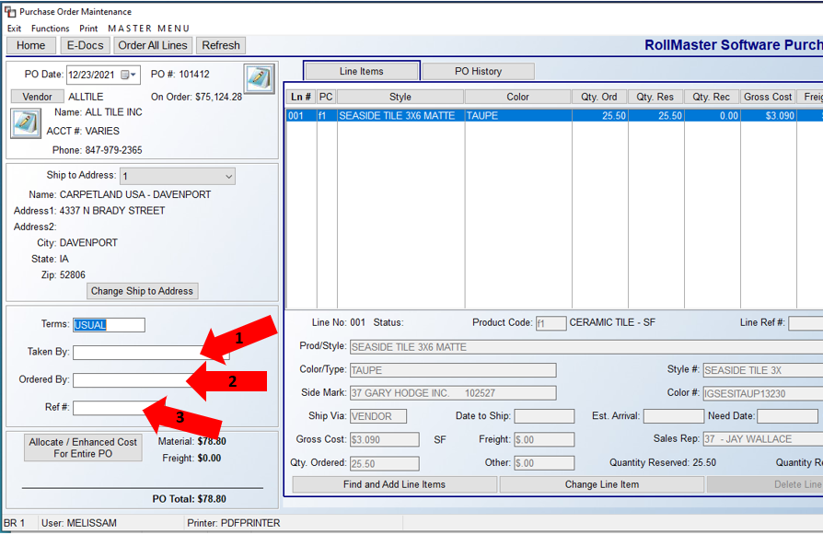

- Fill in Taken By (Person’s name if over the phone or Online) (1), Ordered By (2), and Ref # (3)

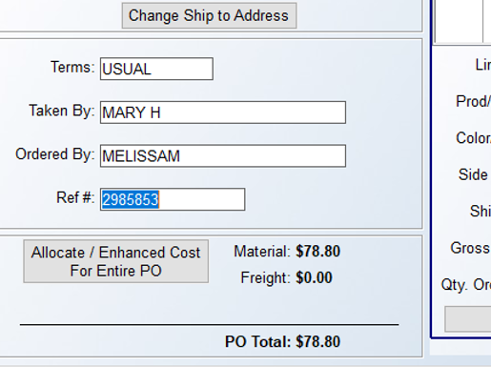

- Select the Order All Lines tab at the top

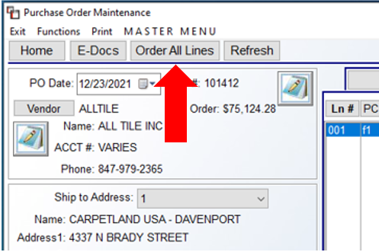
- The following window will open:
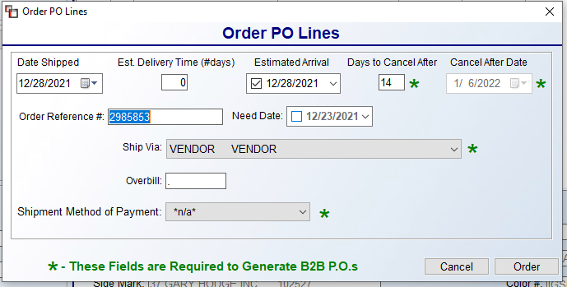
- Fill in the Date Shipped and Estimated Arrival (I use the estimated arrival date for both), Order Reference #, and Ship Via (This will sometimes autofill and other times you will need to select Brauns or will call, etc.)
- After everything is filled in print the PO. Select Print at the top and then Print PO
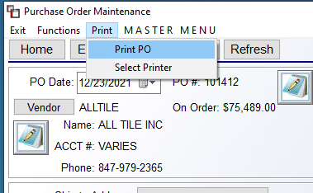
- The following window pops up with the Print Options already selected (The only time I change this is if a PO has already been received and we need a copy. You will need to check the Print Closed Received Lines or it will not print.)

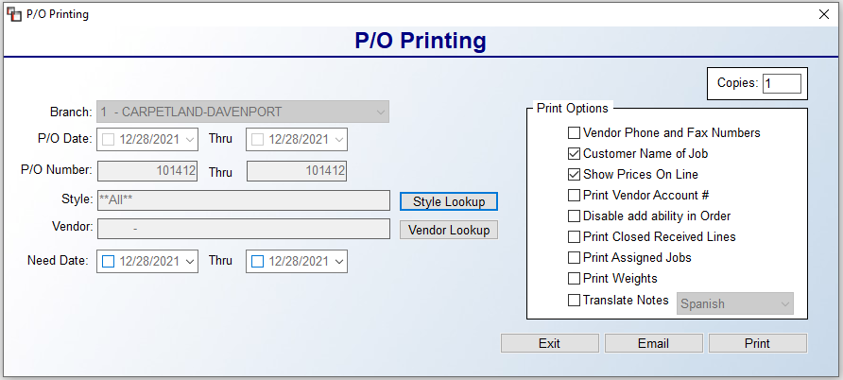
- Make your warehouse tag and file the PO

Ordering Multiple Items on the Same Order
You will follow the same steps as listed above to create a PO.
- Once the PO has been created for the 1st item, right click the 2nd item and select Assign Material Line
- On the next screen select the From PO tab and hit the New PO button as before
- The following will pop up letting you know that there is already a PO assigned to the order
  - If you are using the same vendor click that PO and hit the Select button
  - If you are using a different vendor select New PO

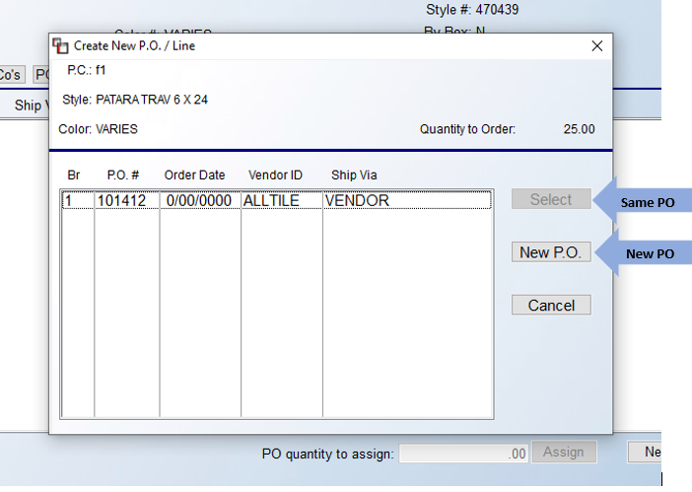

- Follow the rest of the steps to complete the PO

Extra Tip
You can also complete the entire process within the Order Maintenance screen for PO’s that only have one item. I find this method the easiest when ordering one piece of carpet, etc.
- Follow the steps to create a PO
- After the PO is created and it gives you the PO number press OK and the screen will look similar to the following:

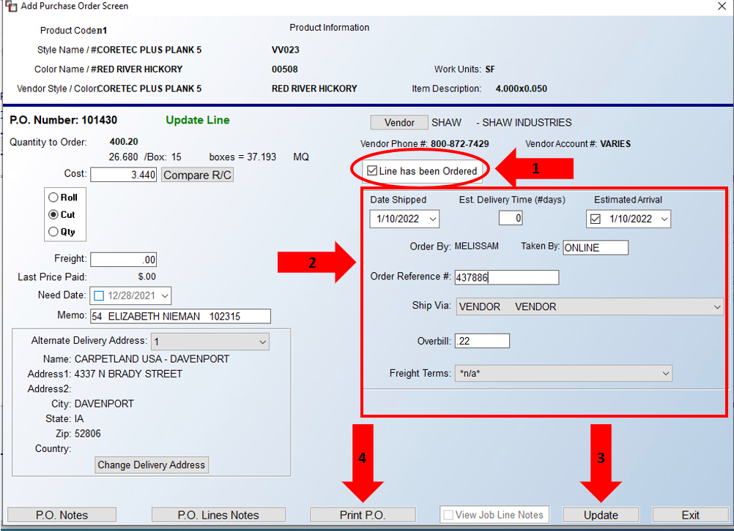

- Check the box for Line has been Ordered (1) and the lines inside the box will become available. Fill in the Date Shipped, Estimated Arrival, Taken By, Order Reference #, and Ship Via same as above (2)
- After everything has been entered click Update (3) on the bottom to save the information then Print P.O. (4)
- Make the warehouse tag and file the PO

