Ordering Stock
- From the Master Menu select Purchase Orders
- Click the New P.O. tab at the top or Create New Purchase Order right above
- Select Vendor and a blank PO will open
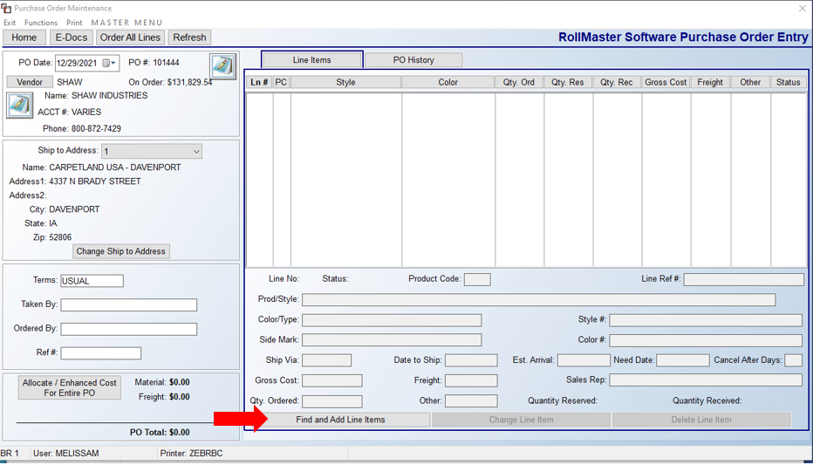
- Click Find and Add Line Items on the bottom and the following lookup screen will open:

I find the easiest way to look up stock carpet is using the Style Number filter but you can also filter many other ways
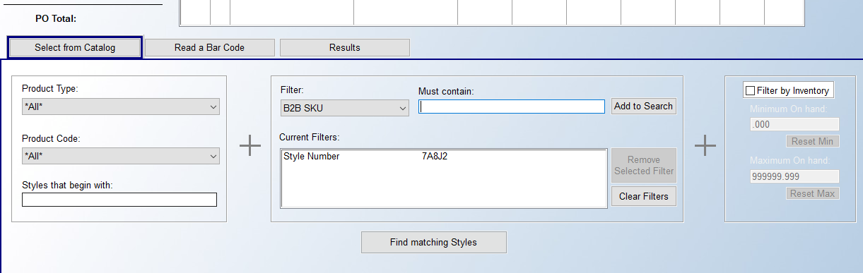
- Select the style and color that you are ordering and click Add Item
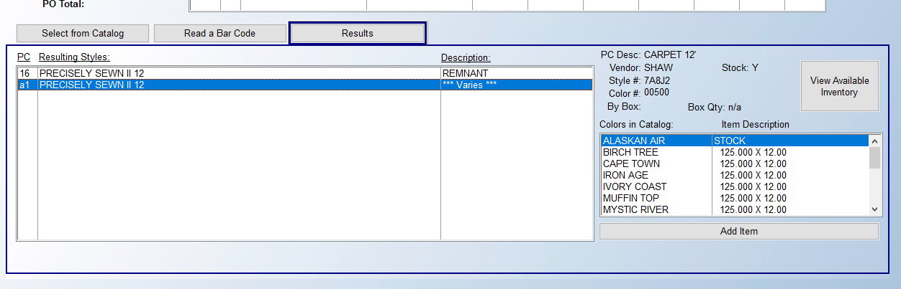
- The following screen will open:
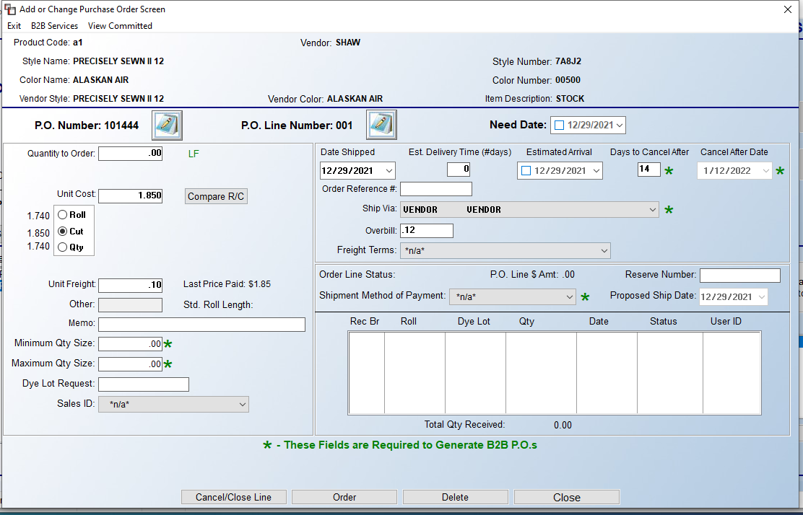

- Fill in the Quantity to Order (if you are ordering more than 1 roll combine the LF together) (1), select Roll and verify price with our Stock pricing (2), add STOCK to the Memo line (3), change Date Shipped (4) and Estimated Arrival (5) (I use the same date, either the actual date provided by the mill or 2 weeks out for in-stock carpet), add the Order Reference # (6), and verify Ship Via (7)

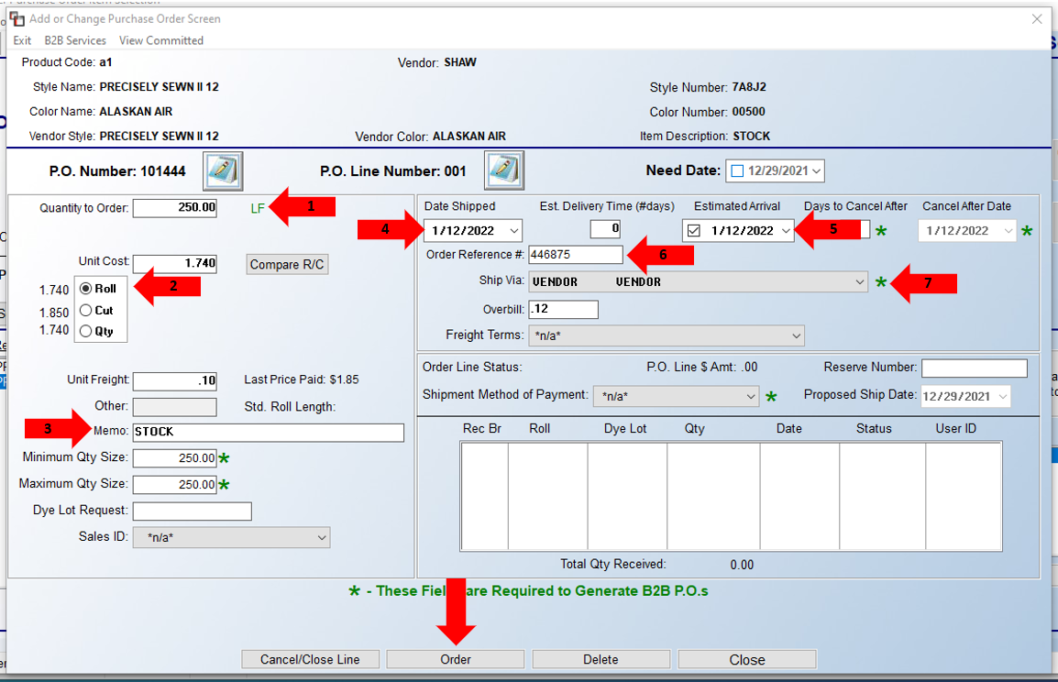

- You can select Order at the bottom, or you can use the Order All Lines tab on the main PO maintenance screen if you have multiple style/colors
- Click Close or Exit when completed

- On the main PO maintenance screen enter the information for Taken By, Ordered By, and Ref # in the lower left corner
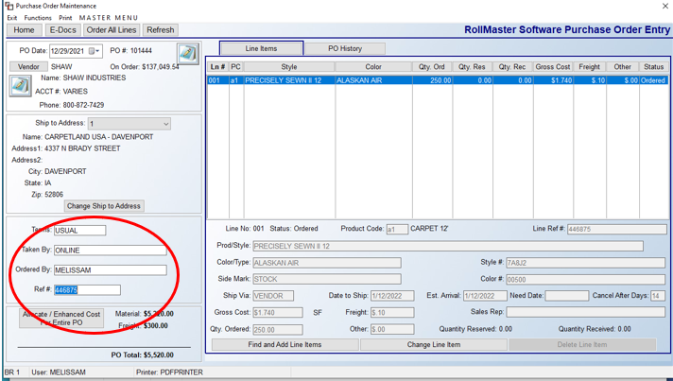
- Print the PO, make the warehouse tag, and file the PO

On the main Purchase Order screen you can easily tell which items are stock by the Y in the Stock column as shown below
